Curriculum Vitae
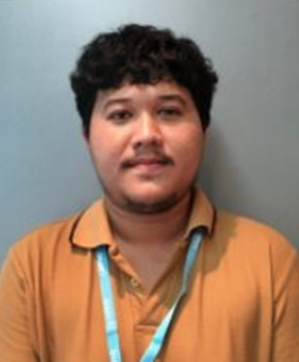
First name: Natthakorn Last name: Nakhaseno Nickname: Tron
Birthday: 6 Nov 1992 Nationality: Thailand
Mail: tron.natthakorn@mail.com Mobile: (+66)92-919-0900
GitHub: https://github.com/TronNattakorn Online CV: https://torlondev.js.org/#/cv
Address: Wireless Rd. Pathumone Bangkok 10330.
History Work & Life
- July 2021 - Present: Learning about cryptocurrency and bitcoin. / Support old company if they contact me for help. (No one contact me about work since December 2021.)
- March 2019 - June 2021: Luma Health Insurance. (2 years 4 months)
Roles: Fullstack Developer + Android Developer + IT Support.
- March 2017 - July 2018: Scale360. (1 year 4 months)
Roles: Mobile & Front-end Developer.
- Feb 2016 - May 2016: Infiniti Global Investor. (4 months)
Roles: Laravel Developer + IT Support.
- May 2014 - Feb 2015: True Corporation. (9 months)
Roles: Trainee programmer.
Dream Work: Work with understanding together for at least 3-5 years++ and more like be family.
Hobby: Play with dog. / Make merit. / Trade crypto.
Salary Expected: Up to company. (Latest 35K THB)

